Secure Copyright Management System

Introduction
This report explains the development of a command-line application written in Python to manage musical artefacts such as audio, lyrics, and scores. The system supports two user roles (admin and user) and lets us store, view, update, and delete artefacts. The system focuses on data privacy and security through encryption, checksums, timestamps, and user permissions.
The design is based on the initial specification from Unit 3, but some changes were made during implementation to make the system more practical and secure.
System Overview
The application is a simple command-line tool built in Python without using large web frameworks. All data is stored in a local SQLite database. Files are encrypted before storage, and each file has a checksum to check if it has been changed. The program also saves important events, including the date and time of creation or modification.
When a user wants to use the system. The program asks them to log in first to make sure they are allowed to use the system. Once logged in, they can add new files, look at files they have already added, change files, or remove files they no longer need.
The main features include:
- Create artefacts: Users can add new music files to the system
- View artefacts: Users can see all the files stored in the system
- Update artefacts: Users can change files they have already added
- Delete artefacts: Users can remove files they no longer need
- Role-based permissions: Different users have different access to use system
- Automatic encryption and checksums: Files are protected automatically
Simple and easy user interface. The system is easy to learn and use.
Each feature is carefully designed to work smoothly with the others. For example, when a user creates a new artefact, the system automatically encrypts it and creates a checksum. The user does not need to do anything extra. This makes the system both powerful and simple to use.
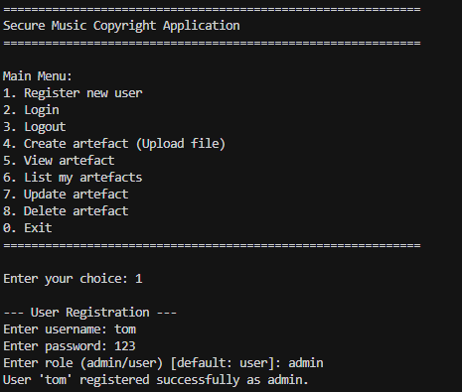
Figure 1: Registering as Admin
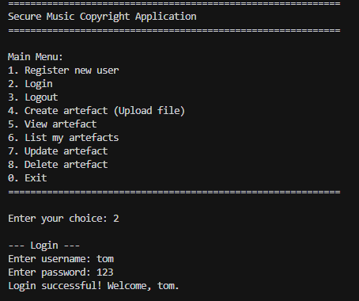
Figure 2: Logging in as Admin.
Technologies Used
Programming Language:
Python 3 (no Django, Flask, or similar frameworks)
External Libraries:
Only one external package was used:
cryptography
This library provides AES-256-GCM encryption. The rest of the program uses built-in Python modules like sqlite3, hashlib, datetime, and os.
External libraries are kept well below the required 20% limit.
Database and Data Handling
The system uses a single SQLite database file. data stored includes:
- Encrypted file data
- SHA-256 checksum
- File type (audio, score, lyrics)
- Timestamp of creation or modification
- The user who added or updated the file
The database is accessed through a single database manager class that handles all read and write operations. This makes the code clean and easier to maintain.
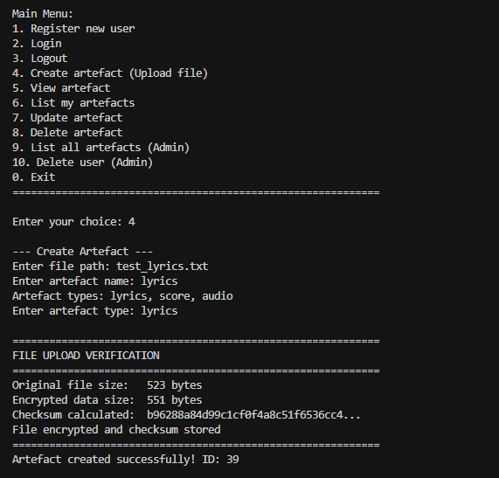
Figure 3: uploading the lyrics file with the checksum saved.

Roles and Authentication
The system supports two roles:
Admin
- Can create, update, and delete any artefact.
- Can view all artefacts and delete any user.
User
- Can create, update, and delete only their own artefacts.
- Can not view all artifacts, only view their own artefacts.
User registration and login are required. Passwords are hashed before storage. There is no plain-text password saved anywhere.
When a new user registers, they choose a username and password. The password is immediately hashed, which means it is converted into a special code that cannot be reversed. Even if someone looks at the database, they cannot see the original password. When the user logs in later, the system hashes the password they type and compares it to the stored hash. If they match, the user is allowed in.
Encryption and File Security
Security is a major part of the system. Each artefact is encrypted using AES-256-GCM. This means even if someone gets access to the database, they cannot view the content without the encryption key.
A SHA-256 checksum is also stored for each artefact. When a file is opened, the checksum is recalculated and compared. If the values do not match, the system warns that the file may have been changed.
Every time a file is created or modified, the system records the exact date and time. This creates a history of changes that can be reviewed later. This is important for copyright protection because it shows when a work was created or last modified.
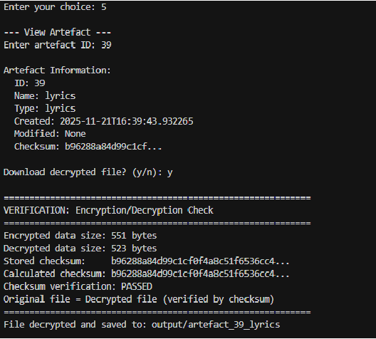
Figure 4: Decrypting the file and verifying the checksum.

Testing and Quality Checks
Automated Testing:
A test script 'test_application.py' is included to check the main functionality of the system. This helps make sure the system works correctly after changes.
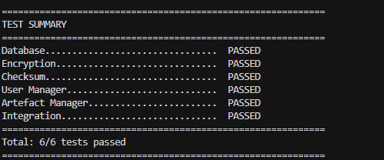
Figure 5: Automated tests passing.
Bandit Security Scan:
Bandit was used to scan the code for security problems. No serious security issues were reported. This gives confidence that the code is safe to use.
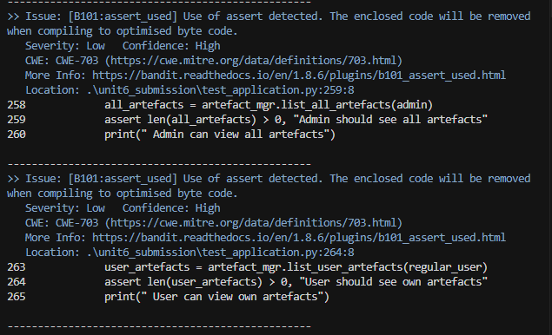
Figure 6: bandit security scan output.

Pylint:
Pylint was used to check code structure, naming, formatting, and logic issues. This helped improve code quality and readability. All major issues were fixed during development.
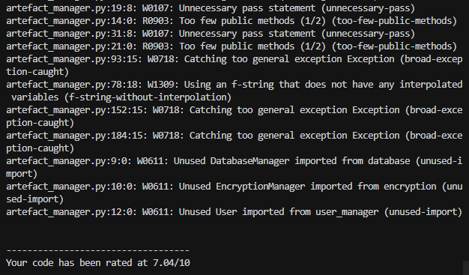
Figure 7: pylint report.

Design Patterns Used
Several simple object-oriented design patterns were used:
Singleton Pattern:
Used in the database manager to make sure only one connection is created. This prevents errors and improves performance. The singleton pattern ensures only one instance of a class exists. This is important for resources that should not be duplicated.
Factory Pattern:
Used when creating encryption algorithms. The encryption factory creates encryption strategy objects (such as AES-256-GCM) without altering the main encryption logic. The factory pattern creates objects without knowing their exact type. This separation makes the code cleaner.
Strategy Pattern:
Used for encryption and checksum methods, so they can be replaced easily in the future if needed. The strategy pattern allows choosing different algorithms at runtime. This makes testing and maintenance easier.

Observer Pattern:
Used to notify the system when database updates happen. Other parts of the program can react to changes. The observer pattern lets one part communicate with other parts when something happens. This keeps different parts in sync automatically.
Inheritance
The user class is the base class, and adminuser inherits from it. Adminuser overrides permission methods to let admins modify and delete any artefact, while regular users can only manage their own artefacts. Inheritance allows creating new classes based on existing ones. This avoids writing duplicate code.
Changes from Unit 3 Design
Some changes from the earlier design were made:
- Instead of blockchain for tracking changes, a simpler timestamp system was used. This is easier to implement and maintain while still recording change history.
- The encryption algorithm was changed to AES-256-GCM using the cryptography library for stronger security and easier usage.
- The database structure was updated to record multiple owners and roles.
These choices reduce complexity while keeping the system secure and meeting academic requirements.
Conclusion
This project successfully creates a secure digital copyright management system with encrypted artefact storage, checksums, user roles, and automated testing. The application is simple to run, easy to maintain, and follows the requirements of the assignment. The approach focuses on practicality and clarity while using design patterns, hashing, encryption, timestamps, and quality testing tools.

References
- Saginayev, E., Niyazov, A., Razaque, A., Kalpeyeva, Z., & Urazgaliyeva, A. (2024) Secure File Storage on Cloud Using Hybrid Cryptography. https://doi.org/10.51301/ce.2024.i2.01 ce.journal.satbayev.university

- B. S. Rawal & S. S. Vivek (2017) Secure file storage and file sharing (review of cloud storage security using AES-based encryption) — referenced in hybrid-cryptography literature. IJARSCT+1
- Viet Vo, Xingliang Yuan, Shi-Feng Sun, Joseph K. Liu, Surya Nepal & Cong Wang (2020) ShieldDB: An Encrypted Document Database with Padding Countermeasures https://arxiv.org/abs/2003.06103 arXiv+1
- Peter Shah & Won So (2015) Lamassu: Storage-Efficient Host-Side Encryption https://arxiv.org/abs/1510.05028
- Kumar, A.K., Anfah, K., Hariharan, T., Parveen, R., Mahmud, S. & Sharma, S. (2023) Secure File Storage on Cloud Using Hybrid Cryptography https://www.journalijar.com/article/44265/secure-file-storage-on-cloud-using-hybrid-cryptography/ journalijar.com
- Dalave, C. V., Lodh, A. A. & Dalave, T. V. (2022) Secure the File Storage on Cloud Computing Using Hybrid Cryptography Algorithm. https://doi.org/10.22214/ijraset.2022.41332 IJRASET
- Chaudhari, A. & Bhaladhare, P.R. (2023) A Survey on Hybrid Cryptography for Secure File Storage on the Cloud https://doi.org/10.22214/ijraset.2023.54089 IJRASET
- Kurian, K., Nair, L. S., Joby, P.P., Rinu Maria Jose, R. M. & John, R. M. (2023) Secure File Storage in Cloud Using Hybrid Encryption https://www.ijert.org/secure-file-storage-in-cloud-using-hybrid-encryption IJERT
- Rani, N. U., Danish Anjum, S., Vishal, K., Hemanth Reddy, N. & Shahid Akram, S. (2023). Repository and Retrieval of Data using AES Security in Cloud Computing Environment https://doi.org/10.22214/ijraset.2023.51255 IJRASET
- Hebbal, P., Ramaje, G., Biradar, P., Kumar, P.R. & Deepika Dash (2025) Secure File Encryption using AES with Password Protection – IJSREM https://ijsrem.com/download/secure-file-encryption-using-aes-with-password-protection/ ijsrem.com
- Maji, S. (2025) Secure File System Implementation (Python + AES-GCM + RSA + SHA-256 + RBAC) https://medium.com/%40maji1996souvik/secure-file-system-implementation-8d4fea5696c9 Medium
- Vo, V., Yuan, X., Sun, S.-F., Liu, J.K., Nepal, S. & Wang, C. (2020) ShieldDB: An Encrypted Document Database with Padding Countermeasures https://arxiv.org/abs/2003.06103

